AS you start the program you will see Main Menu as in below Image.

At first it will ask you for the valid folder path.

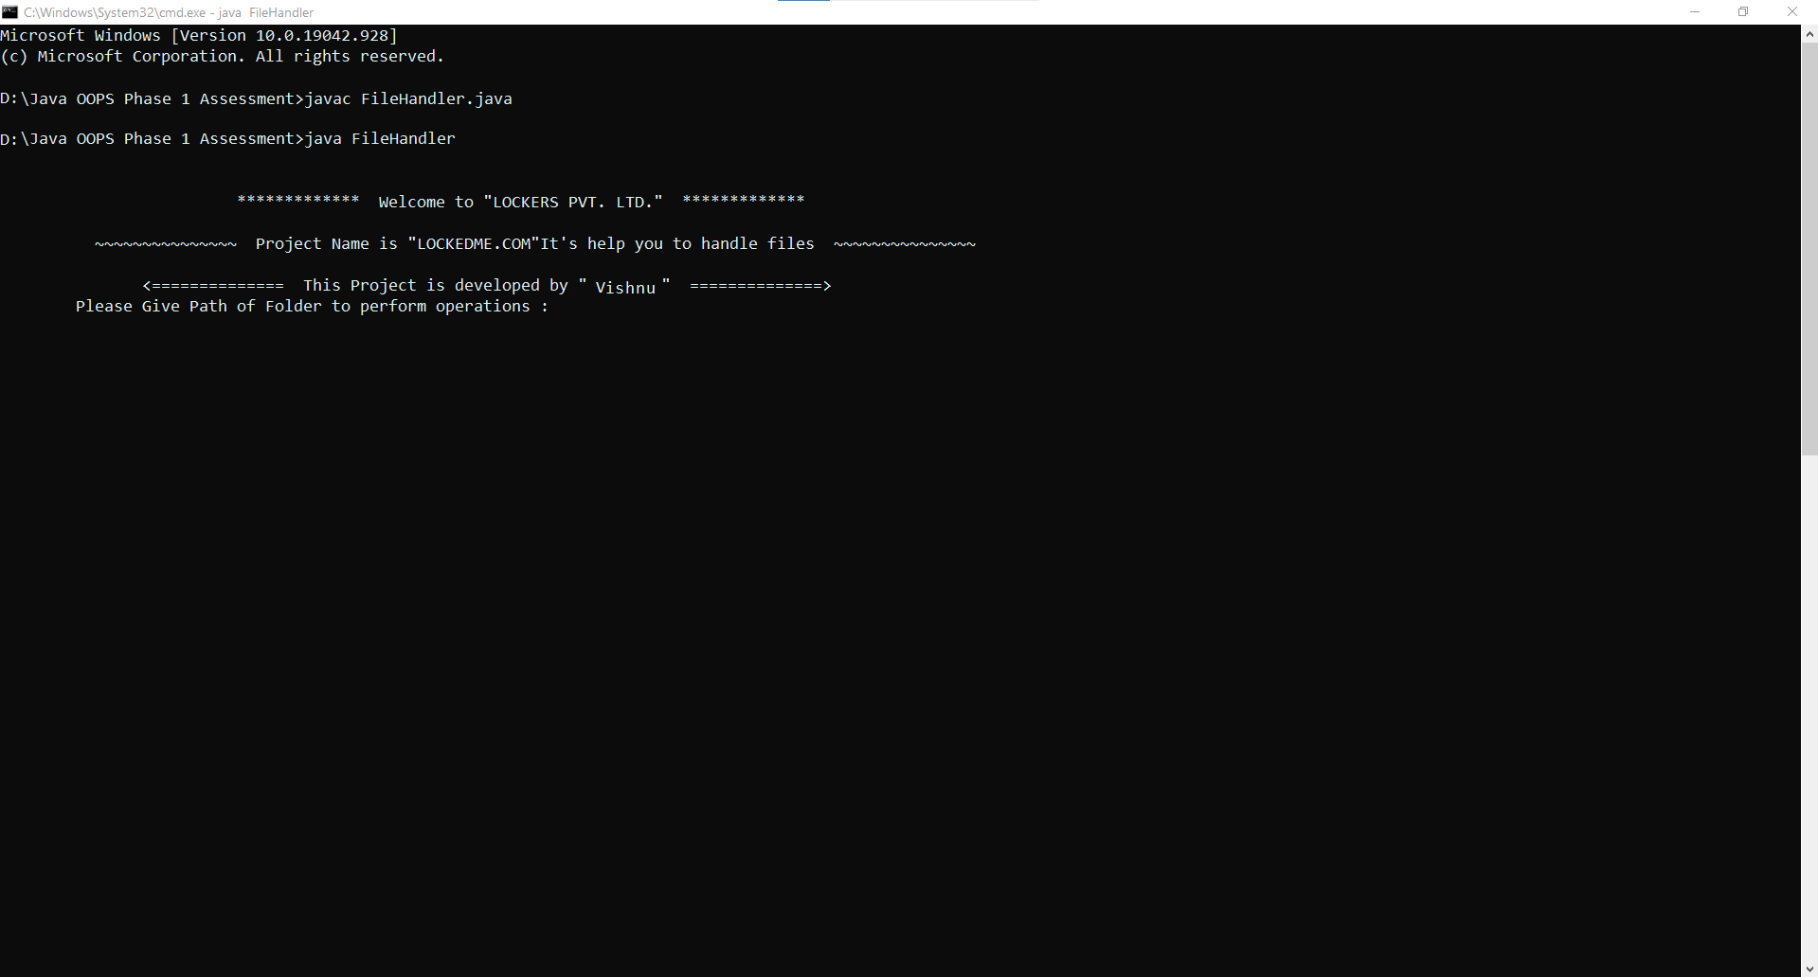

As you can see I had given invalid path but still it asking till it get valid or existing folder path.

In This image you could see the Main Menu.

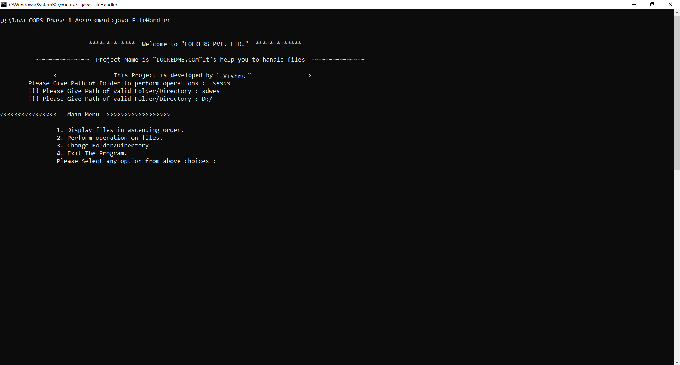

As you can see if I given invalid input, it wil ask me till I give it a valid one. And do operations on given input.

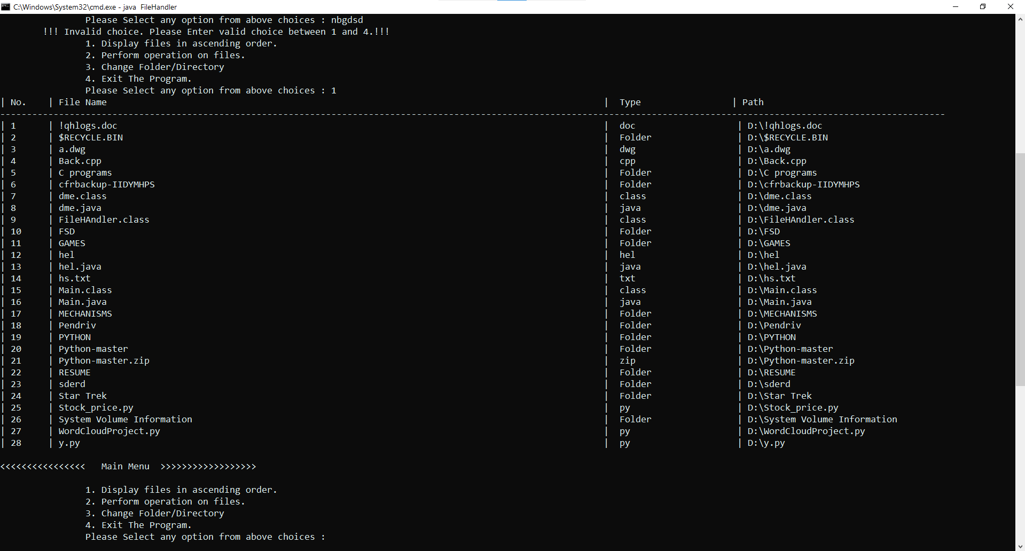

As I give 1 as input it will display all the files in ascending order (with respect to file name) with their type and path. And after displaying files it will redirecting me to main menu.

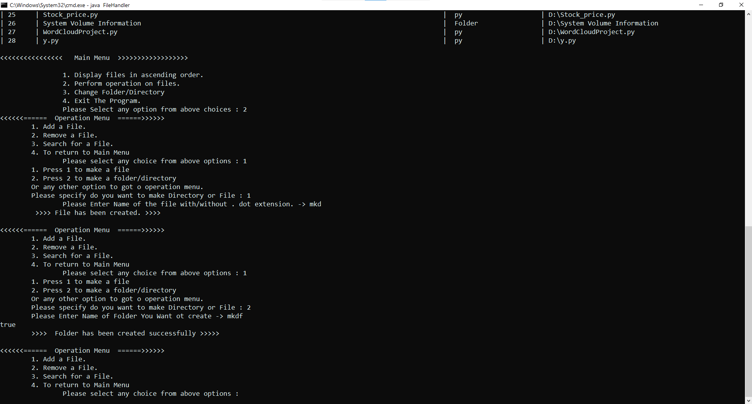

We have two option either to add a file or an empty folder in same current directory.

After successfully creating the file or folder it will return the message.

If we Provide file/folder name which are already present it will show message as below.

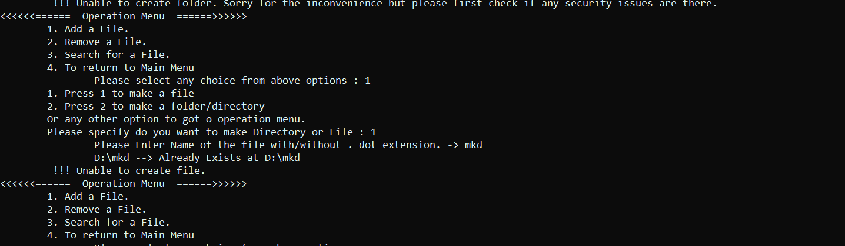



File Deleting operartion as you can see in below image and understand clearly that if we try to delete the file which does not exist it will show message.

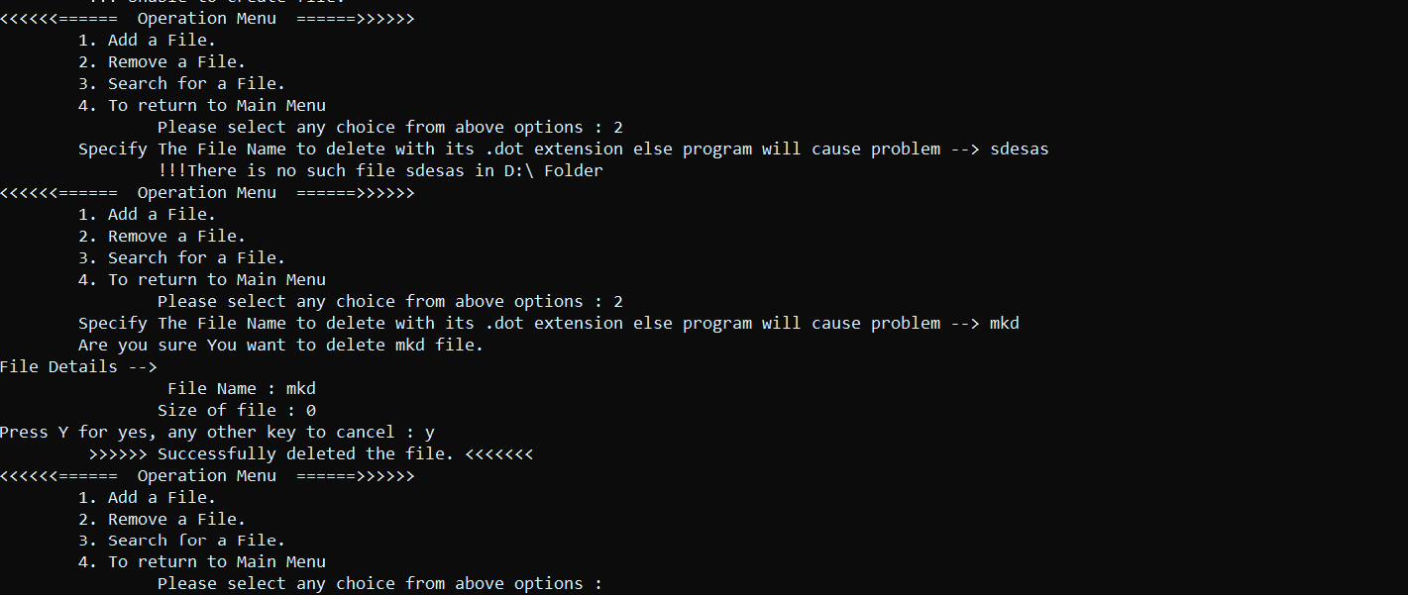

File Searching demo. It is case insensitive. If you donty give extension still also it will display files for you.

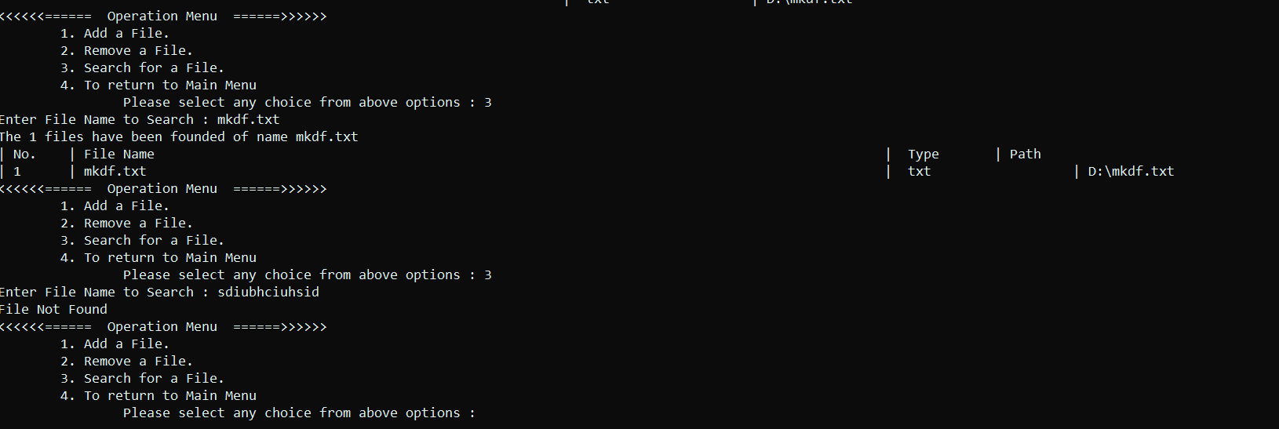

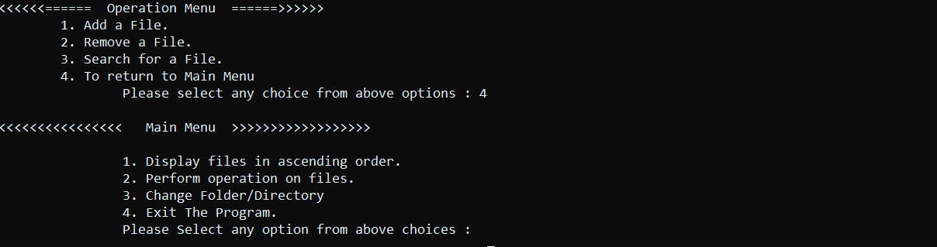

4th option will return us to Main Menu

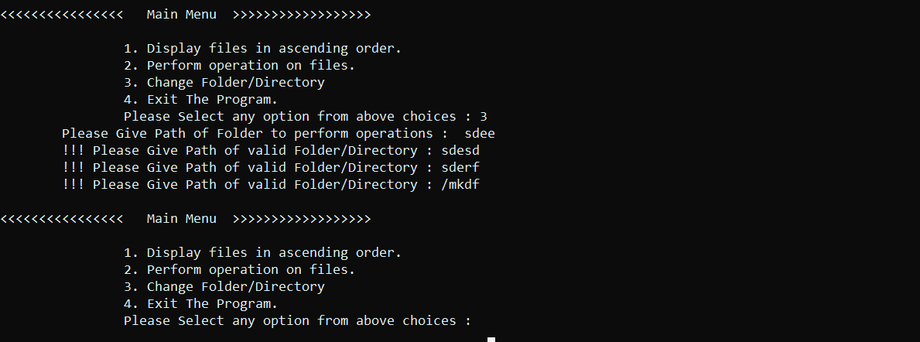

3rd option in the Main Menu will allow you to change your current directory.

It is also handle invalid input in same way.

While 4th option in the Main Menu will help you to exit and close the program safely.

